**STOCK MARKET PREDICTION USING SVM**

Prediction of stock market is a long-time attractive topic to researchers from different fields. In particular, numerous studies have been conducted to predict the movement of stock market using machine learning. In this project, we propose a new prediction algorithm that exploits the time series features and fundamental features like low debt of both the various financial products to predict the next-day stock trend with the aid of SVM

**Algorithm Used**

**SVM**

Support Vector Machine [1] is a renown supervised algorithm which is used to perform the task of classification[2]. Support Vector Machine is used to perform various classification tasks such as Face Recognition [5] , Pattern Matching , Image Analysis etc. . The simplest case of a SVM is linear SVM[6] in which data are linearly separable or in other words it can be separated by a dividing hyper plane . Our Goal is to find the equation of hyper plane that best divides the group with maximum distance separable distance . Let the equation of hyper plane be given as wtx+b is defined for all data points that have a class yi = -1 ,

Wtx+b <-1

and for points with class yi = 1 ,

wtx+b > 1

Here we should have no points between hyper planes wtx+b = -1 and wtx+b = 1 , a region called ‘Margin ‘ . The dividing plane is the function wtx+b = 0 and we classify new points by the sign yi = sign(\wtx+b) . we want to select parameters for the hyper plane that maximize the size of the margin

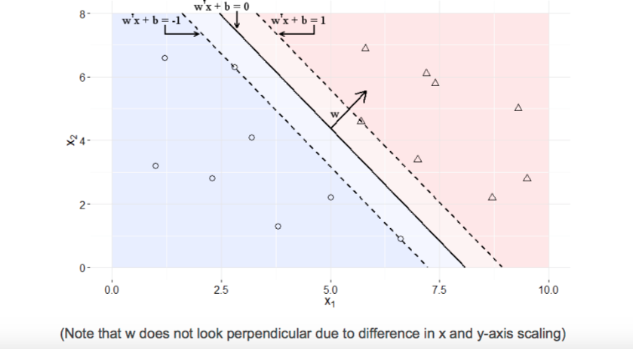

**Software Requirements**

* Python
* Sklearn
* Beautiful Soup etc